Experiment 1:
Aim:
To demonstrate confusion matrix using python
Program:
# Import libraries
import numpy as np
import matplotlib.pyplot as plt
import seaborn as sns
from sklearn.metrics import confusion_matrix
from sklearn.model_selection import train_test_split
from sklearn.datasets import load_iris
from sklearn.linear_model import LogisticRegression
# Load dataset
data = load_iris()
X = data.data
y = data.target
# Split dataset
X_train, X_test, y_train, y_test = train_test_split(X, y, test_size=0.3, random_state=42)
# Train model
model = LogisticRegression(max_iter=200)
model.fit(X_train, y_train)
# Predictions
y_pred = model.predict(X_test)
# Confusion matrix
cm = confusion_matrix(y_test, y_pred)
print("Confusion Matrix:\n", cm)
# Visualization
plt.figure(figsize=(6,4))
sns.heatmap(cm, annot=True, cmap='Blues', fmt='d')
plt.xlabel('Predicted')
plt.ylabel('Actual')
plt.title('Confusion Matrix')
plt.show()
OUTPUT
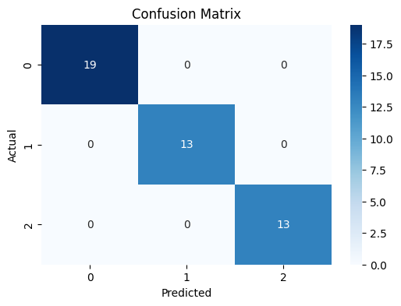
Confusion Matrix:
[[19 0 0]
[ 0 13 0]
[ 0 0 13]]

